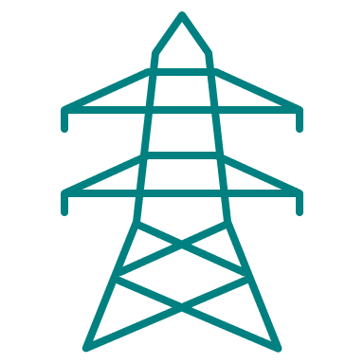

Grid Capacity Review
Scrutiny Committee Task & Finish Group
Background briefing

Contents

1. Introduction 1
2. What is the objective of the review? 2
3. What is the grid? 2
4. How the is grid changing? 4
5. What are ‘DNOs’? 5
6. How is demand forecast? 7
7. Business Planning 11
8. What are the constraints locally? 12
9. How is policy changing? 13

Introduction
The energy crisis threw into sharp relief the challenges posed by the UK’s lack of energy self-sufficiency, and strengthened national ambition to transition from volatile and costly fossil fuel imports to an energy system that is cleaner, low carbon, more secure, and more affordable for consumers. We’re thus entering a period of major change in how the country generates, stores and transports electricity.
Government and Ofgem have released many policy documents and reform proposals over the last couple of years on how to get towards that, including a national commitment to decarbonise the grid by 2035.
Critically, though, this requires not just deployment of renewables, but ensuring that the grid itself is fit for purpose in order to absorb new generation and the significant demand growth expected from the electrification of heat and transport.
A constrained grid that lacks capacity to absorb new supply and demand presents barriers to our achievement of net zero and economic growth alike, especially for high-energy industries. This is especially acute in rural areas, and better capacity and efficiency will be key to ensure we’re not left behind.
Already our programmes have faced delays, curtailment or cancellation of programmes owing to prohibitive connection costs or grid strengthening delays which impaired project viability.
But this could get more significant in the future and threaten key opportunities. Our Great South West prospectus identifies that across the region we could together contribute 11% of the UK’s low carbon electricity capacity, but this urgently needs strategic investment in the grid and policy reform to realise.
Network operators already forecast constraints and produce investment plans to try and address them – and council officers feed into these processes. But Ofgem’s ongoing review of local governance of the networks makes this an opportune point to understand the issues better and consider how the council could play a strengthened role.
Through these sessions we hope that members will take the opportunity to consider how we might strengthen evidence of the impacts and strengthen our links with grid stakeholders to ensure future investment fits our own aspirations for planning, economic development and net zero.

What is the objective of the review?
In May the Places and Resources Scrutiny Committee determined that this Task and Finish group should be established to review grid constraints and produce recommendations back to scrutiny.
We think that this could serve three overall objectives:
- Growing your understanding and awareness on the issues to enable you to confidently engage and advocate on our grid challenges.
- Gathering some further evidence from key stakeholders on the impacts and possible solutions.
- And, most critically, strengthening our links with network operators and forming a view of the best way we can interact with them in the future.
The review will be structured into five sessions taking place into the early part of 2024.
- Session 1 provides a background briefing to introduce the key terms, roles and processes so that you’re more confident to engage in later sessions.
- In Session 2 we’ll hear from council officers on how grid constraints impact their work, and then in the third session similarly from local stakeholders outside the council.
- In Session 4 we’re hoping to hear from grid stakeholders themselves, to understand more about ongoing reforms and investment plans.
- And finally in Session 5 you’ll have the opportunity to take stock and agree recommendations on next steps to take back to scrutiny.
This background briefing covers the basic background terms, roles and processes. It doesn’t detail what constraints are presently, what they’re forecast to be, and what investment plans are – that will form the content of future sessions and briefings.

What is the grid?
The electricity grid is the network of infrastructure responsible for carrying power from where it’s generated to the point of consumption by a home or business. In a nutshell, it comprises a system of overhead lines, underground cables and substations.
Most electricity is currently generated at large power plants and generators, which is then transmitted and distributed via the grid.
There are two types of network which make up the two halves of the grid:
- Transmission networks are the high voltage networks that carry energy long distances from major large-scale generators to local area substations.
- Distribution networks are the lower voltage networks that then carries it for the final part of its journey to homes or businesses.
- The two are bridged by substations, which convert high-voltage electricity from the transmission network to a lower voltage so that it can be safely distributed to end users.
- Think of the transmission network as like a motorway (high speed, long-distance), and the distribution network local highways (lower speed, shorter-distance).
Power isn’t converted from high to low voltage in one step, but is in fact stepped down in multiple stages through different kinds of substation on its journey to homes and businesses:
- Grid Supply Points convert to 132Kv
- Bulk Supply Points convert to 66kV or 33kV
- Primary Substations convert to 11kV
- Distribution Substations convert to 400 or 230 volts, for use by household electrical devices.
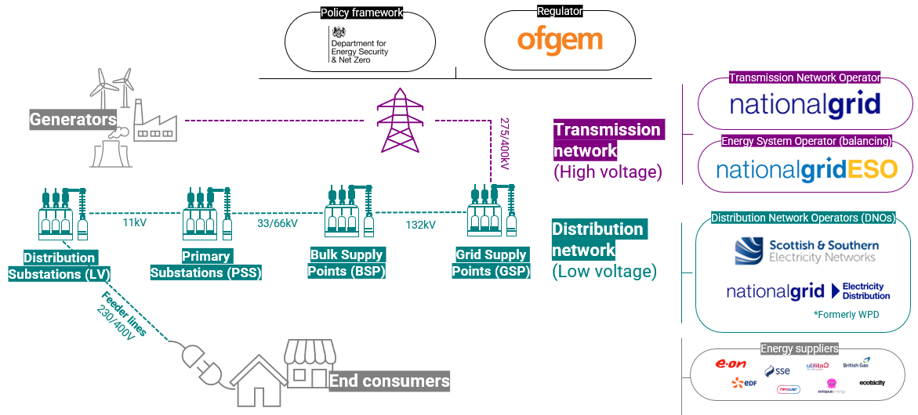
Fig 1. The grid and key stakeholders
The main operational roles for the grid are:
- The role of the Transmission Network Operator, which owns and maintains the transmission network – that is fulfilled by National Grid.
- The role of the Energy System Operator, which manages and plans the supply and demand balance to ensure the network is stable and secure. In England this is fulfilled by National Grid ESO, a separate company.
- And the role of the Distribution Network Operators – regional monopolies who are licensed distributors which own and maintain the distribution network in specific areas.
The system is governed by government and the regulator:
- The Department for Energy Security and Net Zero sets the policy and legislative framework;
- Ofgem sets the common regulatory framework and monitors compliance; licenses generation, transmission and supply; and approves strategic investment plans. As the system is a monopoly, it also has a role in enforcing price controls to protect consumers.
Energy suppliers are distinct from all of these. They buy electricity from the market and sell it onto consumers – so suppliers are an intermediary between consumers and the grid. They forecast what customers electricity needs are and buy an expected amount from the wholesale market. Discrepancies between that and actual demand are managed by National Grid’s balancing services.

How the is grid changing?
There are really two main challenges to focus on: decentralisation and demand growth.
Historically power generation has happened remotely from large settlements, and the grid was designed to have electricity coming one way from a centralised source, through a top-down system.
But increasingly the system is becoming more decentralised and multidirectional, due to:
- First, the connection of many more local generators which are plugging directly into the distribution network (what are known as ‘embedded’ generators), like commercial or community-owned renewables or those installed on homes like rooftop solar.
- And, second, the expected increase in flexible technology like batteries and vehicle-to-grid chargers that can store and export energy back to the grid
This matters for two reasons:
- First, infrastructurally, it means increasing demand for connections to the grid, which can in turn prompt the need for ‘reinforcements’ to the network to ensure that it is capable of absorbing them.
- Second, operationally, the grid needs to be highly responsive to balance – reacting dynamically in real-time to match supply and demand. If they don’t match there’s a risk of outage or a change in the network frequency or voltage that can cause damage (think of it as like maintaining water pressure). Before, we only really needed National Grid to do that balancing nationally as supply was centralised, but now local network operators are having to take on that role too.
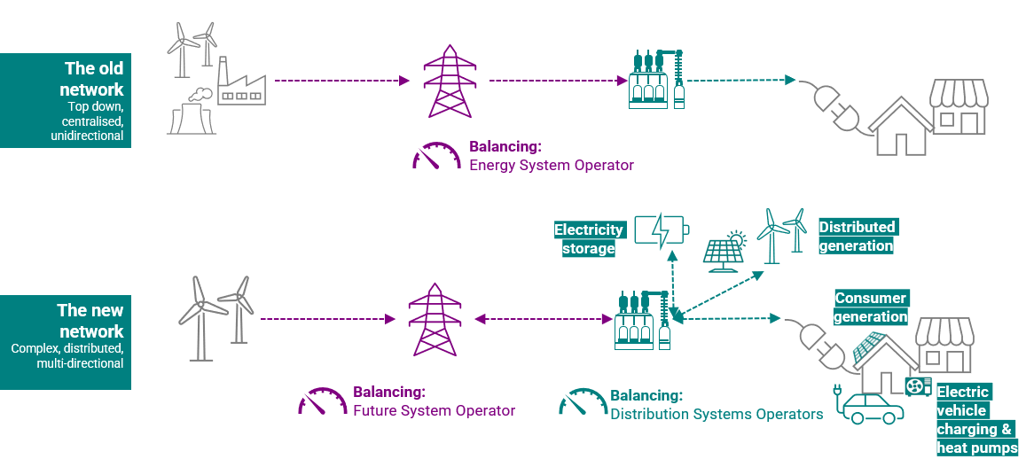
Fig 2. Decentralisation
The second main challenge is the scale of expected demand growth. The key point is just that demand could double to 2050 due to heating and EV charging.
The magnitude, speed and composition of that demand growth varies depending on what scenarios you consider – more on scenarios shortly – but hopefully this just illustrates the general point that demand is expected to grow significantly, and that means more supply is needed and more pressure on the grid to accommodate that additional demand and supply.
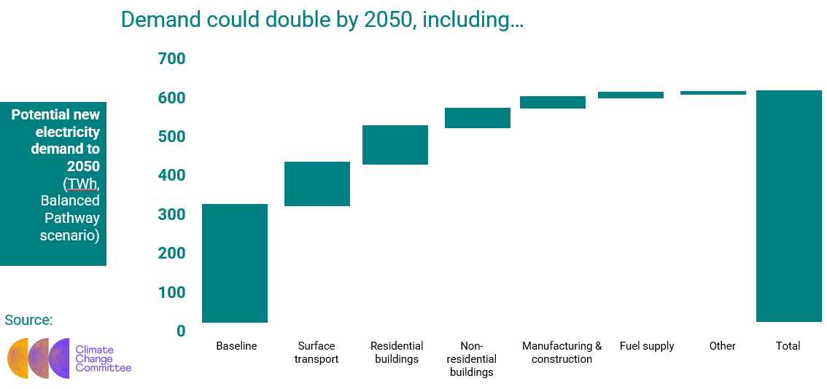
Fig 3. CCC’s forecast of electricity demand growth

What are ‘DNOs’?
Distribution Network Operators (DNOs) are licensed distributors who own & maintain local distribution networks in specific ‘license areas’. In Great Britain six companies run fourteen license areas. These areas aren’t really distinct systems, so power can flow between them and these volumes are measured.
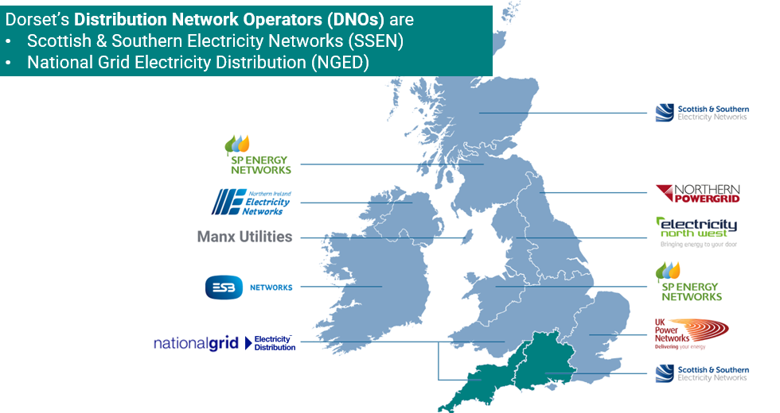
Fig 4. DNOs in the UK and Ireland
Dorset has two DNOs: Southern and Scottish Energy Network (SSEN) and National Grid – and the areas which they cover expand far beyond Dorset, across the Southern and South Western license areas respectively. The Southern area, for instance, covers 53 local authorities.
SSEN covers all but three of Dorset’s substations, which are operated by National Grid (formerly by WPD).
DNOs have a responsibility to ensure capacity for future demand and cost-effective reinforcement. That may be through upgrades to expand or install new substations, overhead lines or underground cables. Generally, the higher up the grid you go (from Primary Substations to Bulk Supply Points to Grid Supply Points) the more expensive and time-consuming works are.
Reactive reinforcement may be required due to either incrementally greater demand from existing connected customers, or by being triggered by requests for new connections.
Requested new connections need to connect to either a modified or new line; and they may (but not always) require an upgrade through reinforcements. DNOs help provide projects with estimates of the costs and options. Areas of constrained capacity can be expensive to connect to if they need reinforcements.
Reinforcements that are not triggered by a new connection request are assessed and approved by Ofgem, as the cost is recovered from all customers.
Ofgem also allows for proactive reinforcement of the network in anticipation of forecast future demand if evidenced – as explained further below.
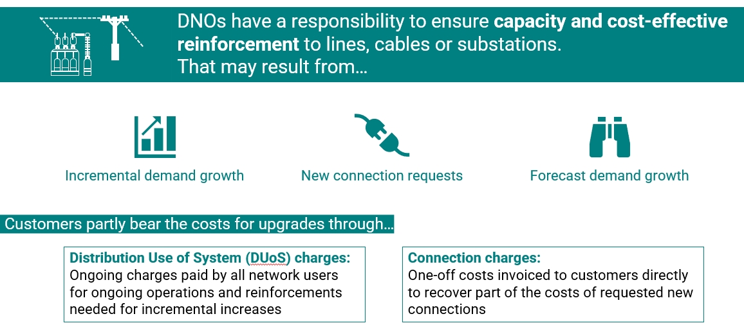
Fig 5. Drivers of upgrades and associated charges
Customers partly bear the costs for upgrades in two possible ways:
- Distribution Use of System (DUoS) charges are ongoing charges paid by all network users in the area, for ongoing operations and the reinforcements needed for incremental increases. They are paid indirectly via suppliers, as a part of the ‘network costs’ element of a customer bill. Similar such charges apply for the transmission network.
- Connection Charges are one-off costs invoiced to customers directly to recover part of the costs of requested new connections, including the connection assets (like cabling or metering) and a proportion of any reinforcement costs. These costs are outlined in Connection Agreements.
From April, charges for reinforcement were removed for demand customers and cut for generation connections. A decision on future distribution use of system charges (DUoS) is expected later this year.
It is important to recognise that – as noted above – DNOs are also increasingly playing an operational role in balancing supply and demand due to the growth in local generation. This means that DNOs are transforming into ‘Distribution System Operators’, in what is called the ‘DNO-DSO transition’.
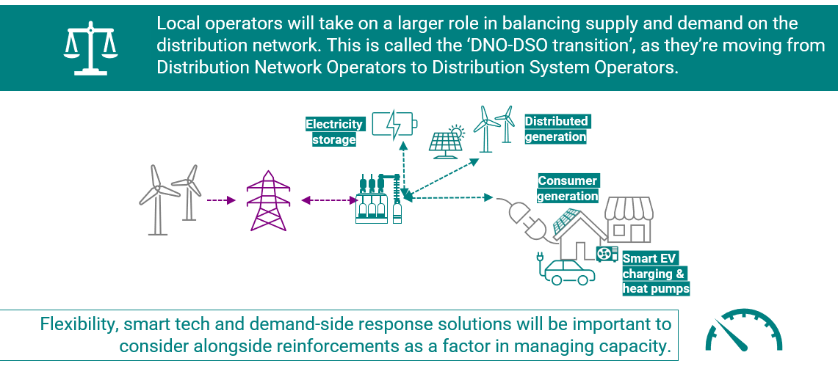
Fig 6. The DNO-DSO transition and importance role of flexibility alongside upgrades
It is important to recognise that managing capacity and ensuring the grid is balanced won’t just involve grid infrastructure upgrades to increase capacity. Flexibility systems like battery storage, demand-management and real time data from smart tech (like smart meters, EV chargers and heat pumps) will also be very important. This will enable them to better manage demand and supply on the local network in real time, and can help to mitigate the need for (and costs associated with) network upgrades. It could also provide opportunities for customers to play a more active role in how the system is managed by, for example, getting paid to adapt their demand, supply power which they generate themselves, or to store electricity if they have the means.
As such, understanding flexibility the role of and value of investment in flexibility technology will be as important as considering grid upgrades. The need to deploy flexibility and smart tech and demand-side response solutions is therefore important to consider alongside reinforcements as an important factor in managing grid capacity. They’re two sides of the same coin when it comes to ensuring future capacity.

How is demand forecast?
Grid operators have a responsibility to ensure capacity for future forecast demand. At the national scale, National Grid prepares its Future Energy Scenarios annually, which outline four potential pathways to 2050.
Each scenario essentially describes a different way to decarbonise the grid – and so make different assumptions over key variables like the extent of investment, household efficiency retrofitting, EV take-up, and the relative role of hydrogen boilers and heat pumps.
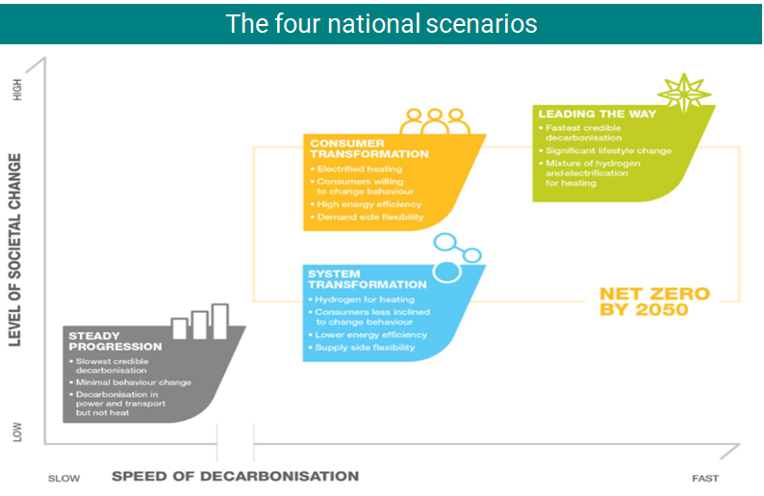
Fig 7. National Grid’s pathways to 2050, which are the basis of forecasting
Consumer Transformation focuses more on changing the way we use energy…
System Transformation focuses more on changing how energy is generated and supplied.
Leading the Way describes the fastest feasible trajectory that is a mix of those two, involving a mix of high consumer engagement, innovative tech and high investment to get to net zero before 2050.
And Steady Progression or falling short is the slowest – and is not in-keeping our national statutory carbon budget and the Paris Agreement.
They correspondingly have different implications for expected peak demand.
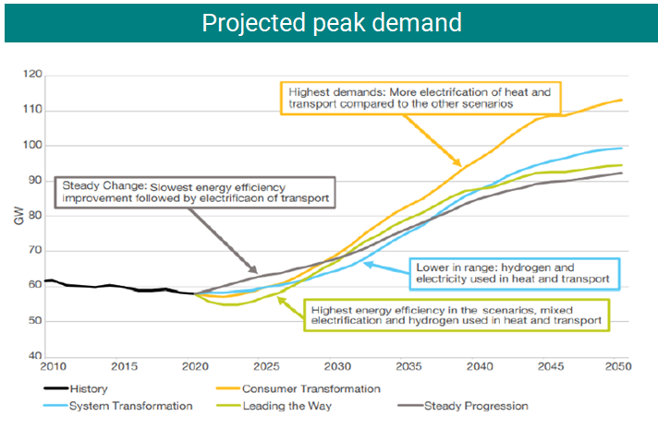
Fig 8. Peak demand implications of those scenarios
Whilst the transition will significantly increase electricity demand, decarbonising is an opportunity to significantly cut overall energy demand – and demand will need to be mitigated by significant energy efficiency improvements. As such, improving energy efficiency of buildings is part and parcel with managing grid constraints – the less efficient our buildings, the higher their energy demand, and the more pressure on the grid.
Figure 9 illustrates an example of how two of those scenarios apply to electric vehicle and heat pump uptake. As shown, the two scenarios encode two different assumptions about the extent and pace of uptake, and so what that means for demand.
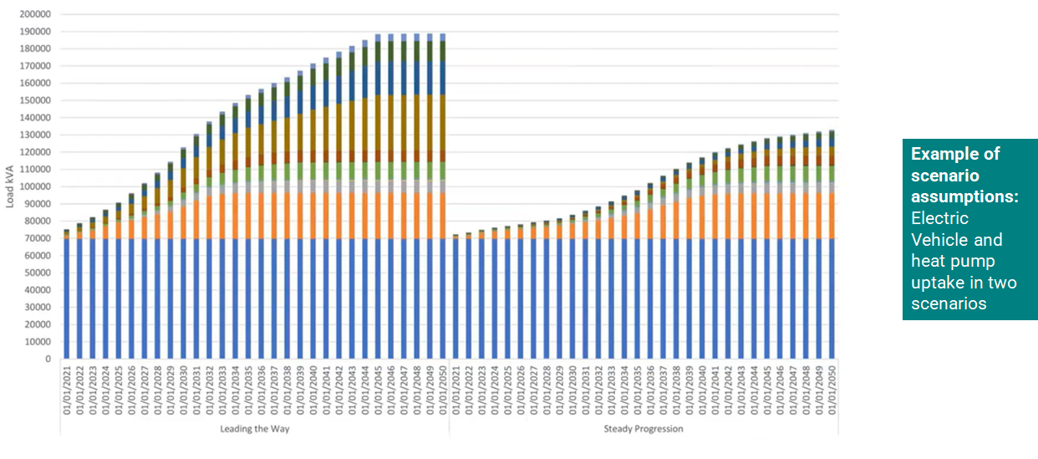
Fig 9. An example of the differences in between the scenarios
Figure 10 shows the contribution of different fuel types in those different scenarios. It illustrates how overall energy demand is cut under all scenarios compared to today, but that electricity makes up a much bigger proportion of our energy use (almost doubling in the Consumer Transformation scenario). This reiterates the point again that we need to see significant improvements in energy efficiency.
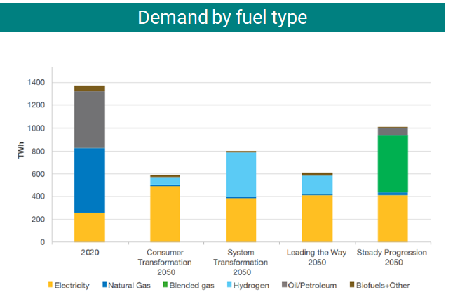
Fig 10. Differences in types of fuel demand in the scenarios
Figure 11 illustrates how the scenarios fit (or don’t) with national carbon budgets. The Climate Change Committee generate the statutory Carbon Budgets to get to net zero, and all but one of the Future Energy Scenarios stay within budget. One – Steady Progression – isn’t compliant with the statutory carbon budget nor the Paris Agreement.
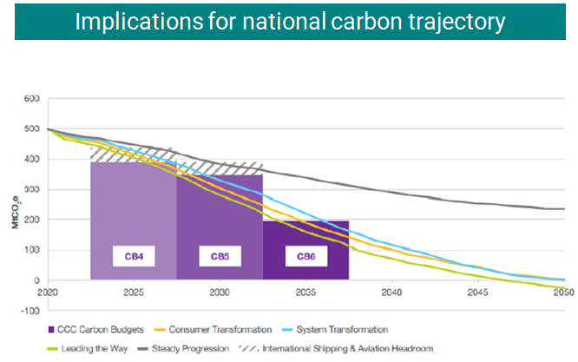
Fig 11. Implications of the scenario for staying within the UK carbon budgets
The foregoing analysis focuses on the transmission level, but DNOs also undertake annual forecasting to 2050 through ‘Distribution Future Energy Scenarios’ (DFES) for the local grid. Both SSEN and National Grid work with Regen to produce these.
They use the same framework, definitions and scenarios as the forecasts just mentioned – but uses more local assumptions and more locally detailed forecasts.
This enables them to credibly forecast what, where, when and how much supply or demand tech might connect to the distribution network. This then allows them to plan for reinforcement through new or expanded substations or through flexibility measures, providing the evidence base for investment.
DNOs model generation, demand and storage in order to anticipate future load scenarios and the location and timing of demand locally.
The modelling considers the baseline of operational or connected projects now, and what’s in the pipeline. It then models to the medium and long-term, and distributes these geographically.
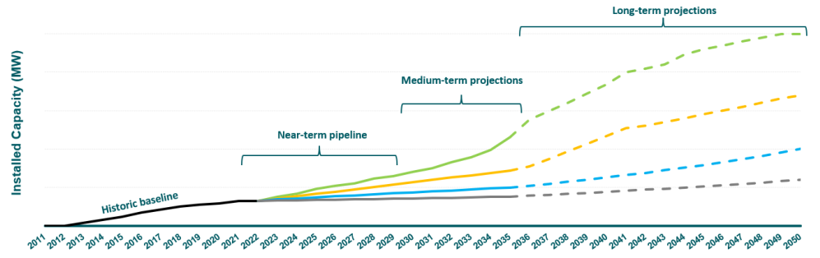
Fig 12. Considerations informing local forecasting
The projections are informed by an evidence base that consider technological and socio-economic factors, consumer behaviour assumptions, local authority strategies and plans, and national policy (like the Future Buildings Standards) amongst other things. There are of course uncertainties on things like policy, tech, and consumer behaviour – and effort is made to factor these into the scenarios.
They are also informed by engagement with local stakeholders, and DNOs hold multiple consultation and engagement events and actively seek information from local authorities - particularly on development and net zero plans. Many council officers input into these processes.

Business Planning
The forecasts are the basis of the strategic investment process, informing a Network Development Plan, Network Options Assessment, and then finally a business case for future investment – such as determining when a Grid Supply Point may need upgrading.
The options assessments include holistic consideration of reinforcement alongside flexibility and demand-side response measures as well as other innovative solutions.
As already noted, as they’re monopolies the network is subject to price controls by Ofgem. These controls are known as RIIO, and they cap the revenue that can be collected from customers.
The Business Plans are produced for 5-year ‘regulatory control periods’ in which investment in which investment is planned. These are submitted to Ofgem for approval and determine the level of investment that can be undertaken in that period. The current price control period for distribution networks is called RIIO-ED2 and runs from this year until 2028.
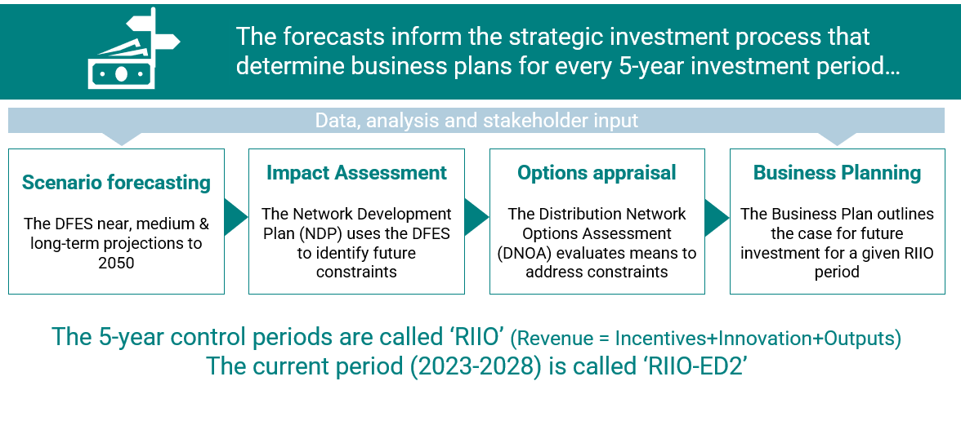
Fig 13. Steps informing investment planning
SSEN’s 2022 plan, for example, outlines a plan to invest at least £3.5bn in the southern license area to 2028, enabling it to facilitate 8GW of distributed generation and storage, 1.3m EVs, and 800,000 heat pumps.

What are the constraints locally?
This document won’t elaborate on the detail of constraints locally, but only a short introduction.
There are three Grid Supply Points that supply Dorset: Axminster, Chickerell and Mannington.
Capacity in Dorset is already constrained, and this is inhibiting project delivery and resulting in the delay, curtailment or cancellation of projects to to prohibitive costs or delays impairing project viability. This is also impacting economic development in areas like Bridport, Weymouth Granby, Portland Port, Holton Heath industrial Estate, & North Dorset Business Park.
The council commissioned our own Grid Capacity Assessment last year as part of the evidence base for the local plan, to identify probable areas of constraint. Under the Consumer Transformation scenario, several local substations are forecast to exceed current capacity by 2030, especially around Chickerell and Dorchester. By 2040, capacity is exceeded at most substations. This will necessitate expansion of substation capacity and the creation of new substations alongside other reinforcements for lines and cables. Demand will also need to be managed through much higher standards for new builds, retrofit programmes, embedded generation and smarter demand management.
We’ll explore this more in future sessions.
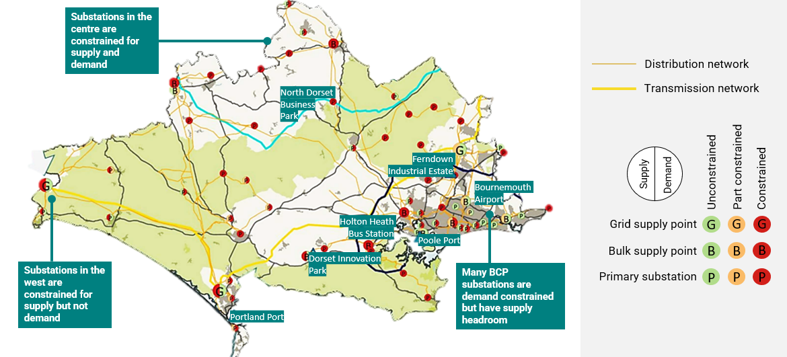
Fig 14. Local constraints currently (2021 Regen analysis)

How is policy changing?
Finally, it is important to note that we are in a period of considerably policy and regulatory change – with Ofgem and government currently midway significant reform. There is too much detail to elaborate on here, so that will be provided in supplementary briefings. However in summary, it is worth being aware of the following at the outset:
- The British Energy Security Strategy released in April last year included several new commitments, including things like 50GW of offshore wind and growing hydrogen production to 10 GW by 2030. It sets the overarching approach for a more affordable, clean, low carbon and secure energy system – and makes some key commitments on things related to the grid.
- Building on that, Government and Ofgem published the Electricity Network Strategic Framework that sets out more on their joint vision and more detail on policy and regulatory reform – covering things like the future role of the system operator, removing barriers to flexibility measures, and improving planning and consenting rules to speed up infrastructure deployment.
- Third, there are key areas around planning and standards that will have important impacts on the future of the grid – including the future for building standards that will determine how much power they use, and of course rules on planning for renewables themselves. Government is also looking at reviewing land rights and consents for energy infrastructure.
- Fourth, Ofgem is midway through its review of charging, covering things like connection charges and ongoing use of service charges.
- Fifth, It’s also launched a review to amend how the queuing system works for connections.
- And finally – and perhaps most important for you to consider – Ofgem is also reviewing future of local energy institutions and governance. This sets out proposals on governance, including the creation of ‘Regional Systems Planners’ which will enable local strategic governance of the energy system.
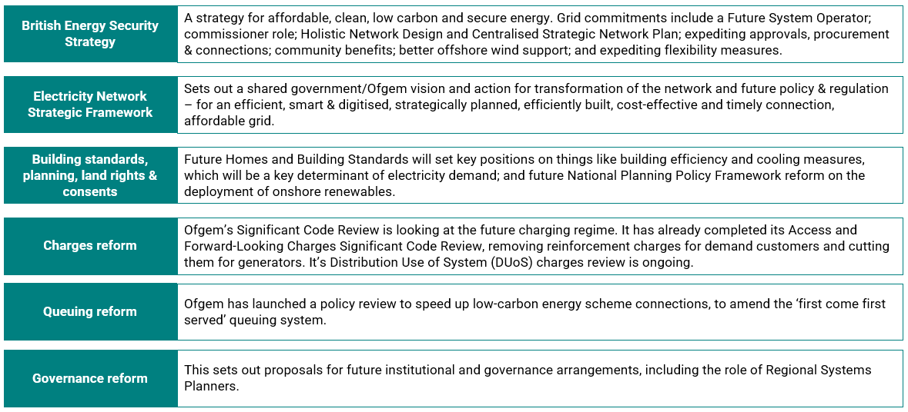
Fig 15. Current areas of major policy reform

